Chapter 9, Solution 50.

Since ω = 100, the inductor = j100x0.1 = j10 Ω and the capacitor = 1/(j100x10⁻³)
= -j10Ω.
20 Ω
5∠40˚
+
v_{x}
−
j10
-j10
I_{x}

Using the current dividing rule:

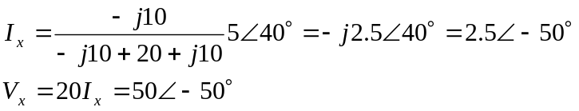

v_{x}(t) = 50cos(100t–50°) V

